South Africa

## Freedom House political status

The data set shows the Freedom House political scores and status of the country each year.

## # A tibble: 19 x 5  
## country iso3c date mean status  
## <chr> <chr> <dbl> <dbl> <chr>   
## 1 South Africa ZAF 1996 1.5 Free   
## 2 South Africa ZAF 1998 1.5 Free   
## 3 South Africa ZAF 2000 1.5 Free   
## 4 South Africa ZAF 2002 1.5 Free   
## 5 South Africa ZAF 2003 1.5 Free   
## 6 South Africa ZAF 2004 1.5 Free   
## 7 South Africa ZAF 2005 1.5 Free   
## 8 South Africa ZAF 2006 2 Free   
## 9 South Africa ZAF 2007 2 Free   
## 10 South Africa ZAF 2008 2 Free   
## 11 South Africa ZAF 2009 2 Free   
## 12 South Africa ZAF 2010 2 Free   
## 13 South Africa ZAF 2011 2 Free   
## 14 South Africa ZAF 2012 2 Free   
## 15 South Africa ZAF 2013 2 Free   
## 16 South Africa ZAF 2014 2 Free   
## 17 South Africa ZAF 2015 2 Free   
## 18 South Africa ZAF 2016 2 Free   
## 19 South Africa ZAF 2017 2 Free

## Freedom House classification of political change

The data set shows the GDP growth and the ecomic growth classification of the country each year.

## # A tibble: 19 x 4  
## country iso3c date politicalChangeFH  
## <chr> <chr> <dbl> <chr>   
## 1 South Africa ZAF 1996 no change   
## 2 South Africa ZAF 1998 no change   
## 3 South Africa ZAF 2000 no change   
## 4 South Africa ZAF 2002 no change   
## 5 South Africa ZAF 2003 no change   
## 6 South Africa ZAF 2004 no change   
## 7 South Africa ZAF 2005 no change   
## 8 South Africa ZAF 2006 autocratization   
## 9 South Africa ZAF 2007 no change   
## 10 South Africa ZAF 2008 no change   
## 11 South Africa ZAF 2009 no change   
## 12 South Africa ZAF 2010 no change   
## 13 South Africa ZAF 2011 no change   
## 14 South Africa ZAF 2012 no change   
## 15 South Africa ZAF 2013 no change   
## 16 South Africa ZAF 2014 no change   
## 17 South Africa ZAF 2015 no change   
## 18 South Africa ZAF 2016 no change   
## 19 South Africa ZAF 2017 no change

## Freedom House score trend

The plot shows the Freedom House scores trend of the country.

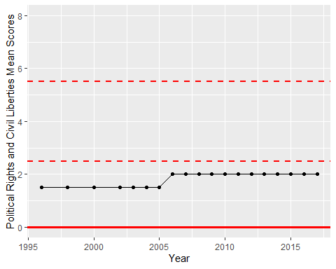

Freedom House Score Trend